Agenda Interview with BU1, BU2, and BU3 (anonymised version)

Welcome
- Explanation of context leading up to the meeting:
  - General questions we seek to answer with the work:
    - Is capturing the data about the processes in a more precise way useful, and if so, how?
    - Which temporal constraints are relevant in a real business model?
  - Assess with industry case: ePO v4.2.0
  - We collected from the public documentation and UML diagrams potentially temporal information and analysed it. Drawing insights and lessons learned; prospects for more precise modelling.
- This interview is part of the analysis phase. Consent-based. Can withdraw at any time and then we delete any notes taken during the meeting and do not use that in the paper to be submitted to the conference.
  - Reporting in the paper, normal course of operation: anonymised, referring to “a business expert” + thank-you to “interview participant” in the acknowledgements section
  - By ethics protocol:
    - Need to say/write either Yes or No before we start with the main part
    - Reminder: You can stop this meeting at any time
- Structure of the interview:
  - Brief introduction to what temporal modelling is about
  - A few general questions
  - Concrete cases with specific questions
  - Any closing remarks you may have
- Your benefits:
  - Be exposed to latest developments in conceptual modelling
  - Can improve ePO quality and precision, and therewith that of the data
  - Can offer new ways of analysing procurement data

Ok?

Explanation of temporal modelling
- Not BPM, but about the modelling of data about the processes, and ensuring that the temporal constraints hold over the stored data, for data integrity, hence, quality and for data analysis.
- Timeline illustration:
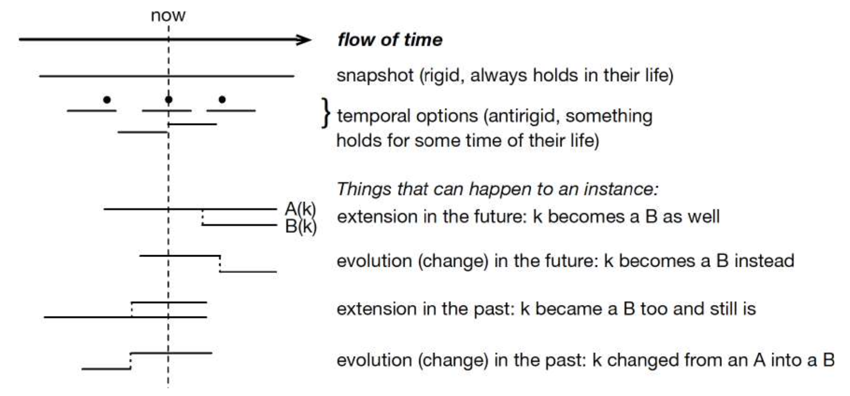

- TRENDy example as illustration
  - not intended that it must happen this way, but might help, despite being in EER notation
  - While the tool (code: https://github.com/richietaylor/trendy, production build: https://trendy-blue.vercel.app/, video: https://www.dropbox.com/scl/fi/q4lso59ymzt0hxap1wkh2/TRENDy-Demo.mp4?rlkey=yp7o8ong4pkhrqu1legw7hqbi&st=74cqpf99&dl=0) is an academic proof-of-concept, the extensive theory behind it has been developed over the past 23 years.
  - Some examples:

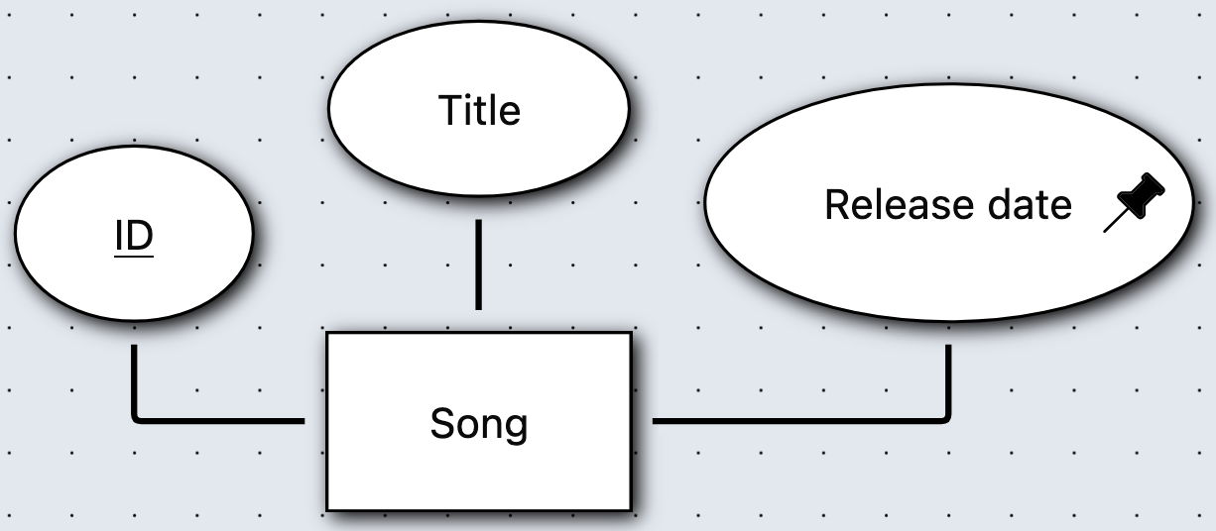

Or, consider a company policy that states that they grow their own timber and managers may not be hired laterally, but only employees can become managers.
Also, that Board members of the company may have been managers, but they can’t be managers for the company at the same time.
This would be modelled with temporal constraints as follows (graphically and verbally, that is, sugarcoating the logic):
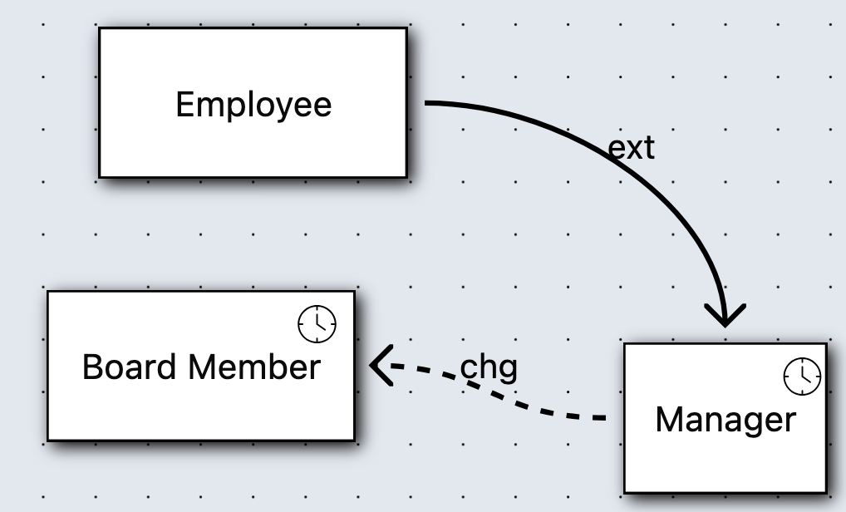

Clicking on the transition constraint:

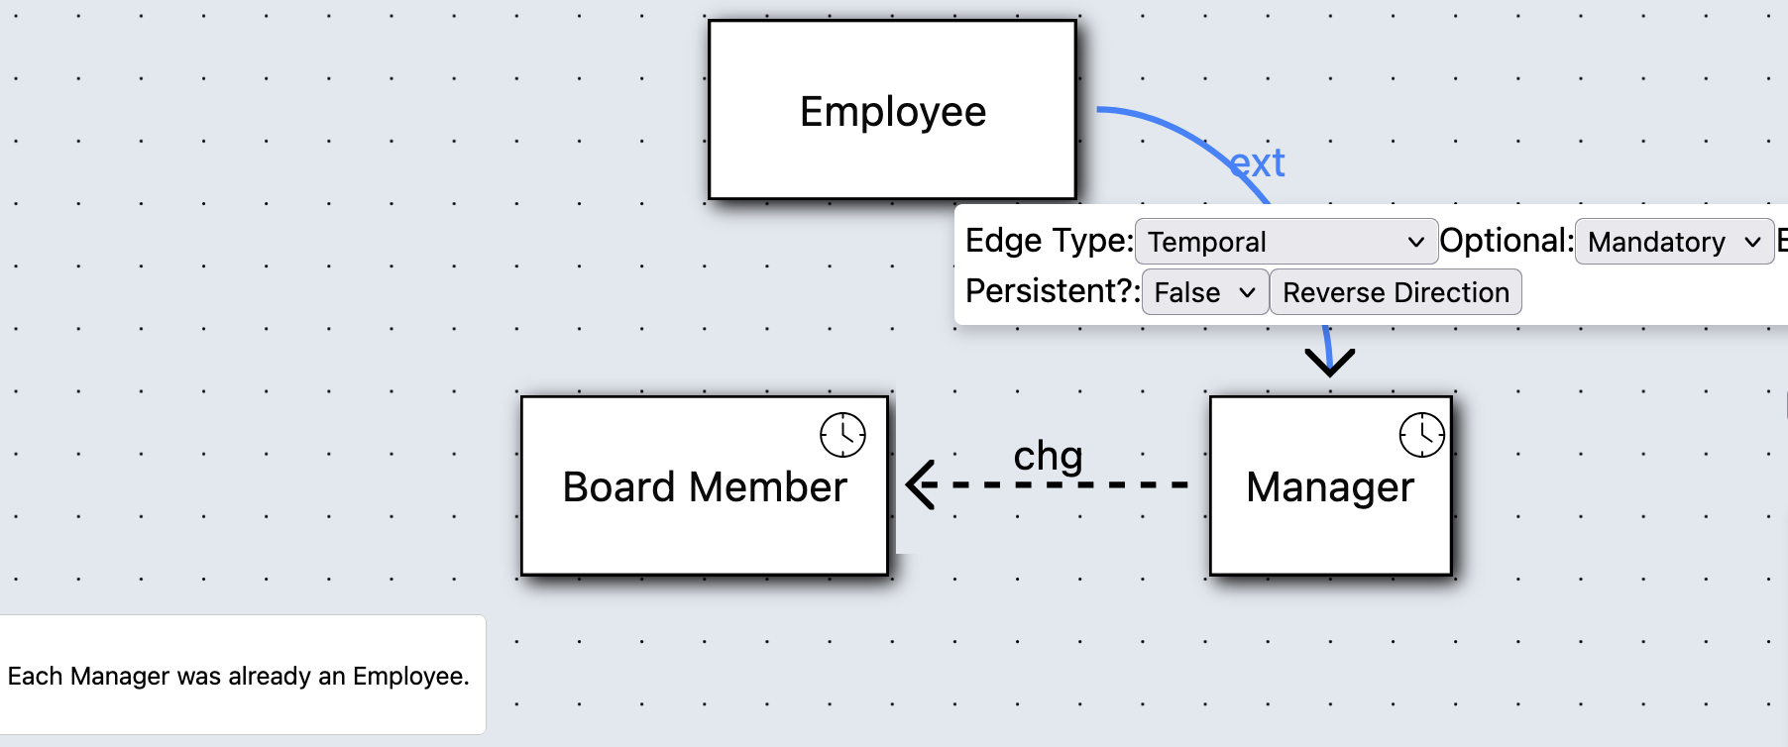

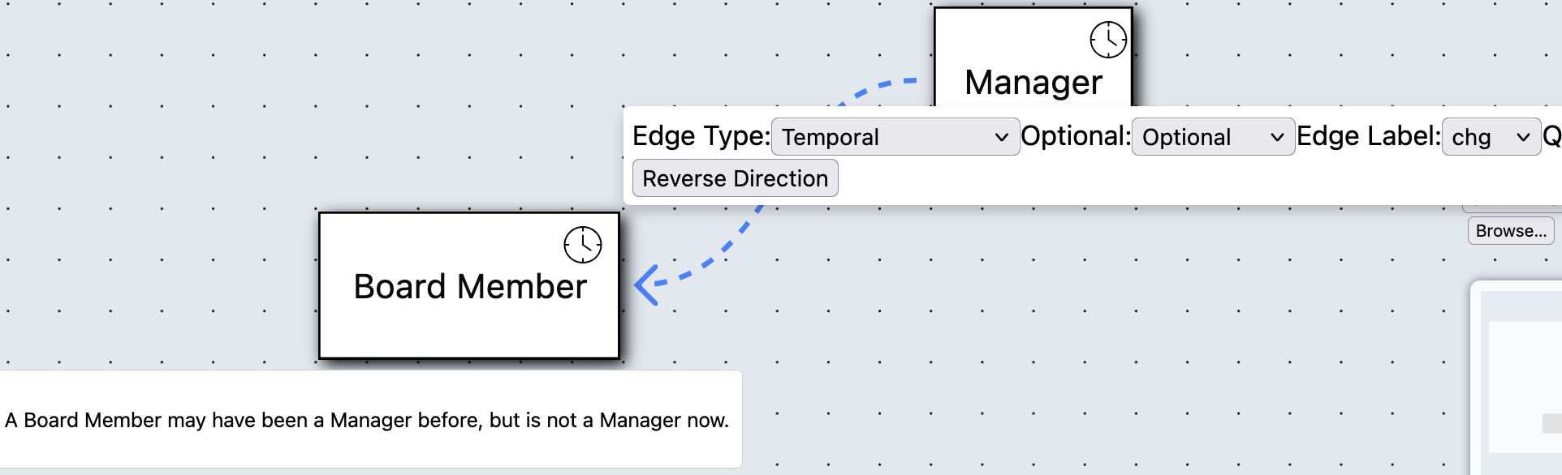

The language features in TREND, summarised:
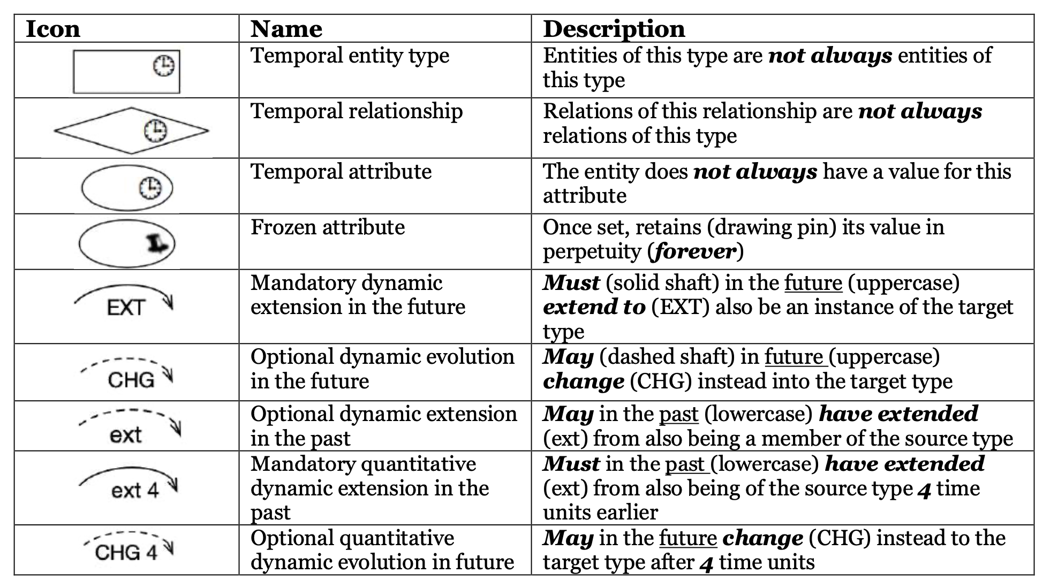

These temporal constraints may, or may not suffice.

Initial questions

General questions:
- Did you ever come across temporal data modelling?
  - Never
  - Only temporal SQL, but not temporal EER/UML/ORM
  - Maybe, not sure
  - Only time and date attributes
  - Yes, someone introduced it before
  - Yes, and I have experience with temporal conceptual modelling before with EER/UML/ORM/Another modelling language
  - Yes, I’m an expert in temporal modelling
- What is your first impression based on this brief introduction?
  - E.g.: not sure, seems pointless, reserve my judgement, not sure but willing to take a look, looks like it might be useful, …

More questions:
<link to back-up questions.doc>

Cases/examples
File emailed: <link to samples cases.doc>

The roles

Introduction

ePO snippet:
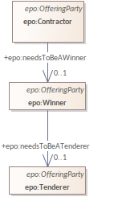
In the eProcurement domain, participants in a procurement process take on different roles over time—such as Candidate, Tenderer, Winner, and finally Contractor. These role changes are not static classifications, but process-driven transitions that are critical for ensuring transparency, legality, and integrity in public spending workflows. Modeling these role transitions temporally is essential for understanding and verifying the lifecycle of a procurement participant.

Problem
“Needs to be” is not enforced in the data that is supposed to comply with ePO, because it is a label/name only. Unless an implementer manually checks and creates an undocumented ad hoc thingie for it.
Traditional ER or UML-based conceptual models capture only static roles. They fail to represent how and when an agent transitions from one role to another (e.g., from a Candidate to a Tenderer). This leads to loss of temporal information, weakened data integrity, and a missed opportunity to enforce key business rules such as:
- A Tenderer must exist before becoming a Winner
- A Contractor must have previously been a Winner

Examples of constraints that can be modelled
Role Transition | TREND Use | Trigger/Event
epo:Candidate → epo:Tenderer | ext (optional past), CHG (optional future) | Submission of a tender
epo:Tenderer → epo:Winner | ext (mandatory) | Result of award decision
epo:Winner → epo:Contractor | EXT (mandatory or optional, depending on context) | Contract signing

Questions - modelling
- Do you check for such constraints in the data now? E.g., that a winner was already in the database as a tenderer, for that lot.
- Is this useful to record?
- (Answers to questions 1 and 2 determine follow-up questions, if any)

Questions - data analysis
- Do you currently analyse the procurement data?
- Would you want to analyse data across time instants? E.g.:
  - How long did it take (on average) for a winner to have become a contractor on that contract?
  - What is the percentage of candidates that eventually become contractors on a given lot/contract?
  - Did an organisation skip the tendering stage and got inserted into the database as a contractor? (is the latter now technically possible and you hope it doesn’t happen? OR not possible through an ad hoc implementation of the constraint in the database

Contract Amendment
Relevant section of ePO v4.2
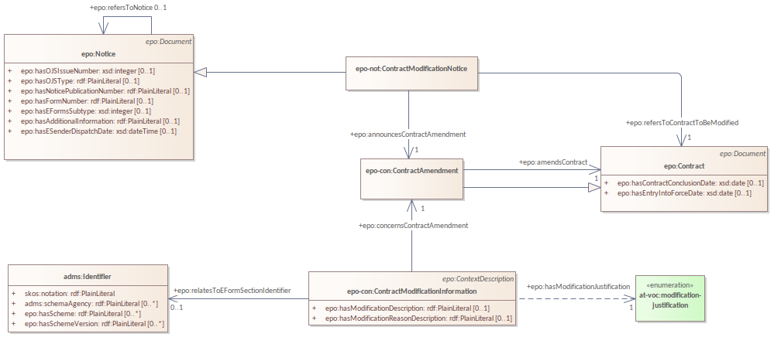

In public procurement, a contract may evolve over time through amendments. These amendments represent discrete events that modify the state of a contract.

Question/problem:
- Is the contract amendment a type of contract?
- During an amendment, does the contract change into a new entity ‘amended contract’?
- Will this amended contract contain only the changes of the contract or contract + changes?

Answers to these questions can resolve how to track documents and how to relate them, and possibly refine the ePO model’s current representation.

PlannedProcurementPart & Procedure/Lot
Planned Procurement Part and Procedure from ePO v4.2:
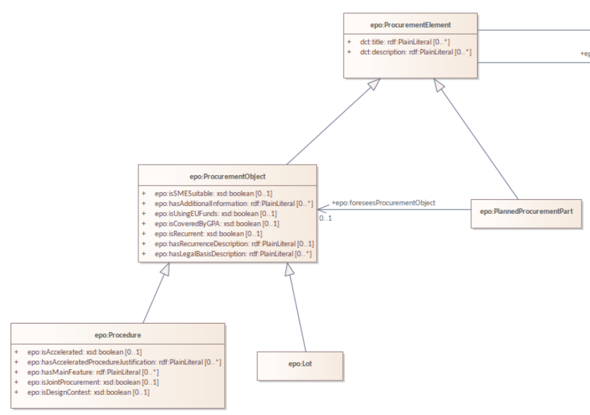

The Procedure & Planned Procurement Part exhibits two different modelling challenges that came afore when we were analysing it on what the temporal relation between the two should be, if any.

Part vs isa vs evolves into

The identity of PlannedProcurementPart and how disjoint/different it is from Procedure:
- Is PlannedProcurementPart a part of a procedure, a type of procedure, or evolves into a procedure? This was left unclear in the atemporal model, but since they are definitely temporally related, it brought up the question how, and therewith also what they really are. Some options that passed the revue in our analysis are as follows (see screenshot below), which are unlikely to be all correct:
  - The “chg” arrow says “Each Procedure was a Planned Procurement Part, but is not now.”
  - The “EXT” arrow: “Each Planned Procurement Part may also become a Procedure”
  - The “ext 6” arrow: “A Procedure may already be a Planned Procurement Part for 6 months.”
  - Note: other options are also possible, but not drawn; e.g., an “ext 6” arrow with a solid shaft would amount to “A Procedure was already a Planned Procurement Part for 6 months.” and adding a pin to the “chg” prevents a procedure from becoming a planned part again, i.e., “Each Procedure was a Planned Procurement Part, but is not now, and remains a Procedure indefinitely.”

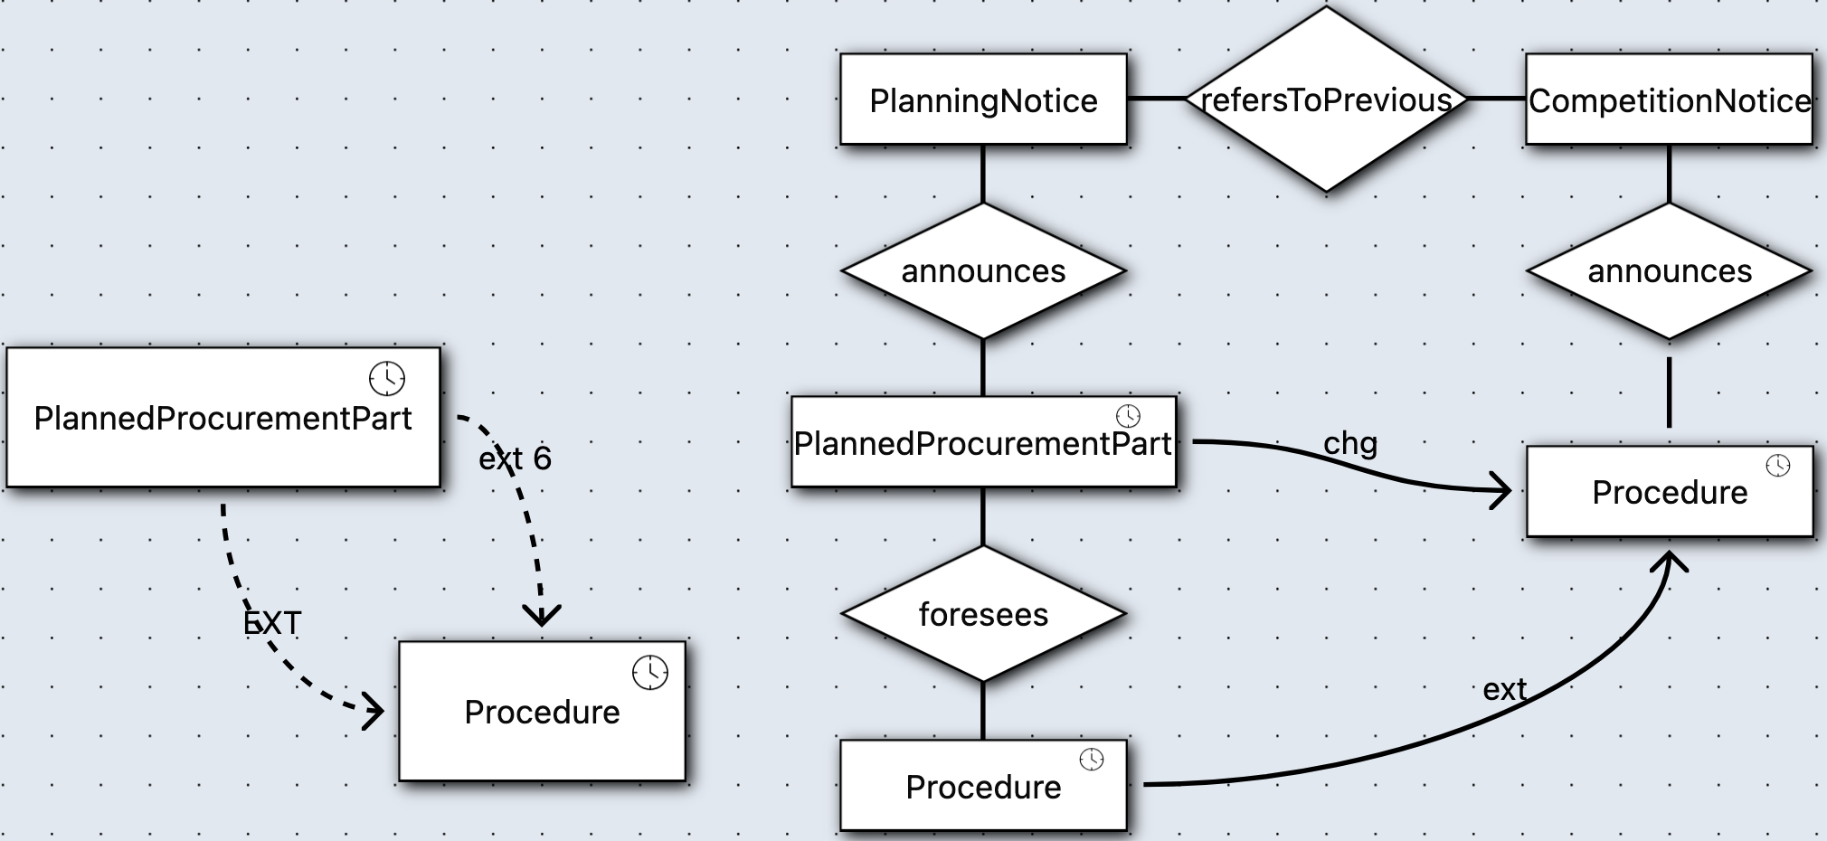

Procedure across notices

Procedure appears twice, but in different notice types, one for planning notices (foreseen by a PlannedProcurementPart) and one for competition notices (with the latter occurring after the former), which we drew in one model snippet during our analysis (in TRENDy, see above, right-hand side).
- The competition notice's Procedure is the one from the planning notice, but with a few more attributes, hence, the initial intuition for “ext”, in that the CompetitionNotice.Procedure was already a PlanningNotice.Procedure. Logically, one would not extend to itself, but to another class that is compatible in the sense of not resulting in an unsatisfiable class or association.
  - Are they the same and should therefore also have the same identifiers? (and be harmonised across models)
  - Are they different, in that the procedure of CompetitionNotice.Procedure would be a subclass of the procedure in PlanningNotice.Procedure, since it has more attributes, and so one was ‘extended’ into the other?

Questions, time permitting

- Would it help to set rules like “a contract can’t start before it’s been awarded”? And if so, that not just buried in the code, but in an (extended) UML Class diagram?
- Do you actually keep track of when things happen, like when a contract starts or ends, and is data integrity required for that? And is so, is that tracking done manually? For instance:
  - That there ought to be some tooling logic that ensures that the end date is after the start date.
  - That there is a notion of (a class) Active/currentlyRunningContracts with instances of current contracts and a class, say, Completed/finished Contracts that individual contracts migrate to once finished?
- Directions & notifications: If an individual contract as instance of Contract has, say, a duration of 3 years, ought it ‘automatically’ move to some other state after 3 years? such as, say, to `ContractWithExtension’ or ‘CompletedContract’.
- Are there any time-related situations you deal with that we haven’t talked about yet, but would be relevant to assess now that you have been introduced to temporal modelling?
- Do you think it would help to design systems that already include time information, not just add it later?

